subTask create

-------------------------



subTask dueDate change

------------------------------------



SubTask, remove duedate

------------------------------------



subTask Assigned

--------------------------



Subtask unassign

---------------------------



subTask comments

-----------------------------

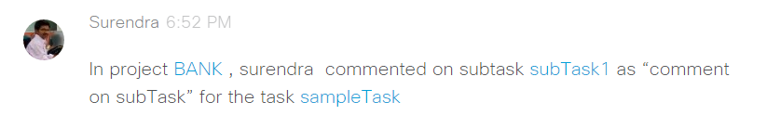

subTask attachment added

---------------------------------------

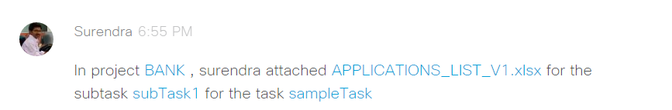

subTask marked as favorite

-----------------------------------------

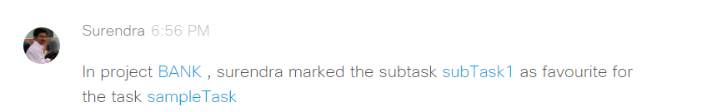

subTask complete

----------------------------

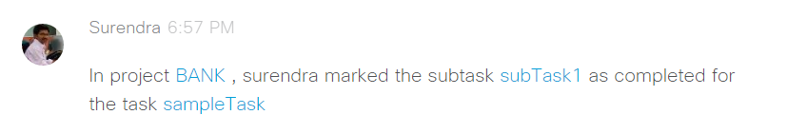

subTask, marking favorite for completing

--------------------------------------------------------

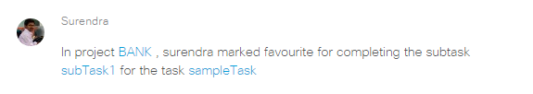

subTask incomplete

----------------------------

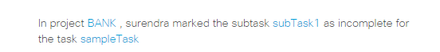

subTask copy

--------------------



subTask mark duplicate

---------------------------------

